Top 1   
**May 4th Visitor Center**

Address: Taylor Hall, Kent, OH

Website <http://www.kent.edu/may4>

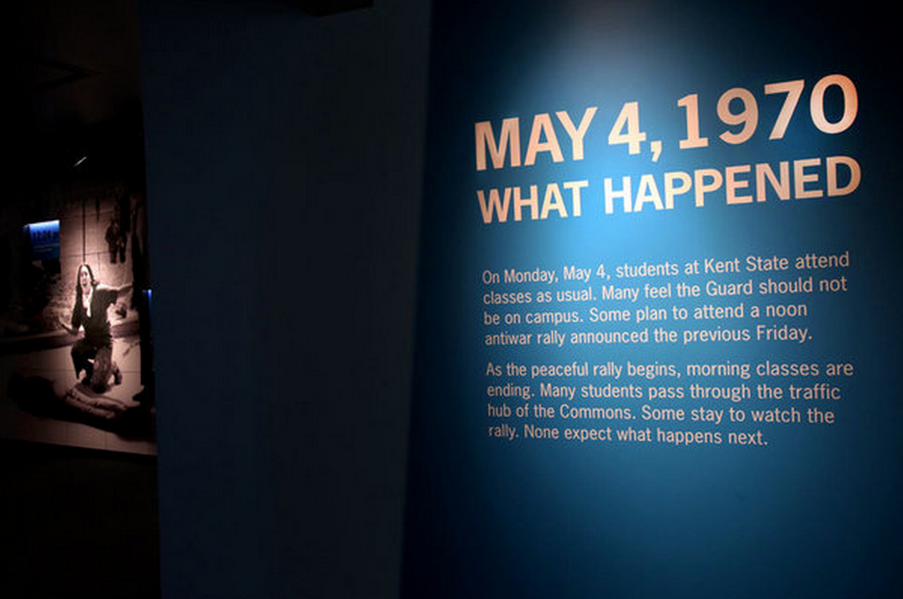

Top 2 **Kent State University Museum**

Address: 515 Hilltop Drive, Kent, OH

Phone Number: (330) 672-3450

Website <http://www2.kent.edu/museum/about/index.cfm#_=_>

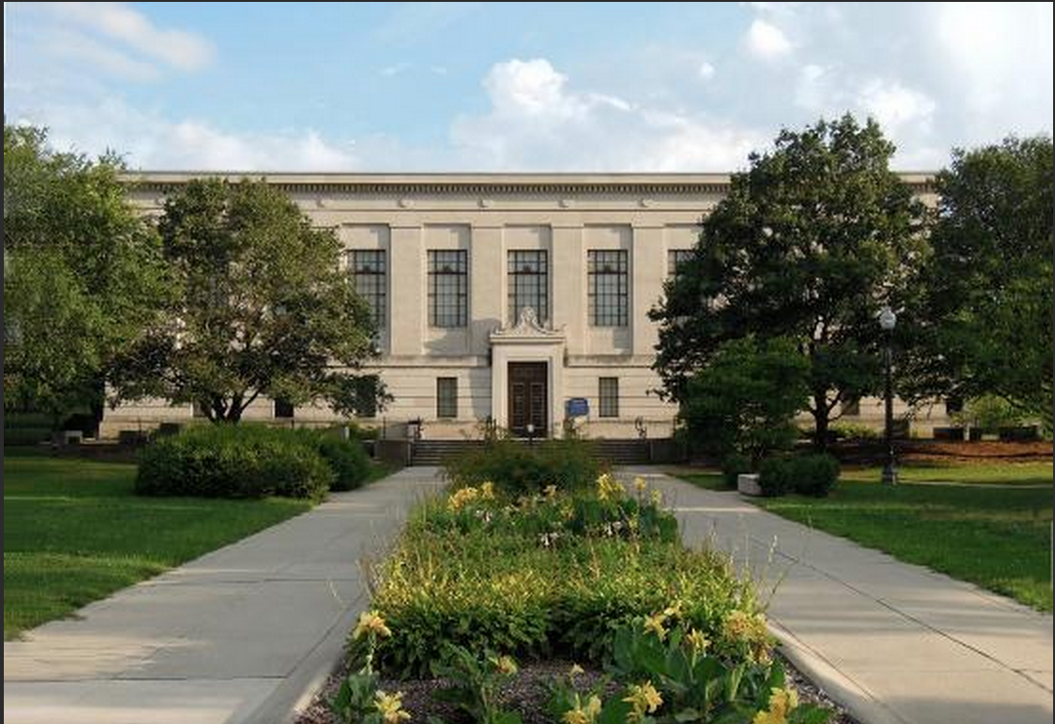

Top 3

Student center & Library

Kent State University Libraries  
P.O. Box 5190  
Kent, Ohio 44242-0001  
330-672-3456

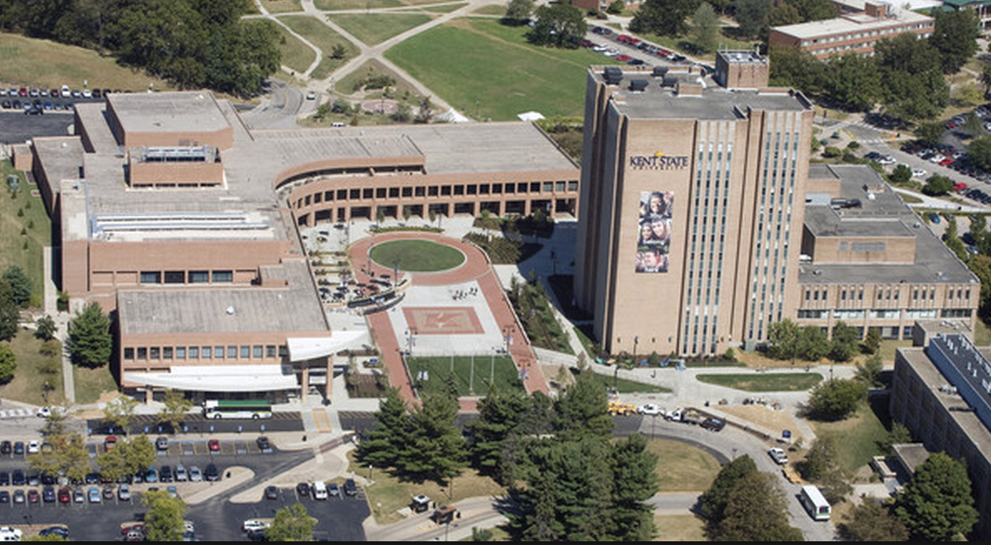

top 4 **Dix Stadium**

2227 Summit Road  
[Kent, Ohio](http://en.wikipedia.org/wiki/Kent,_Ohio), United States

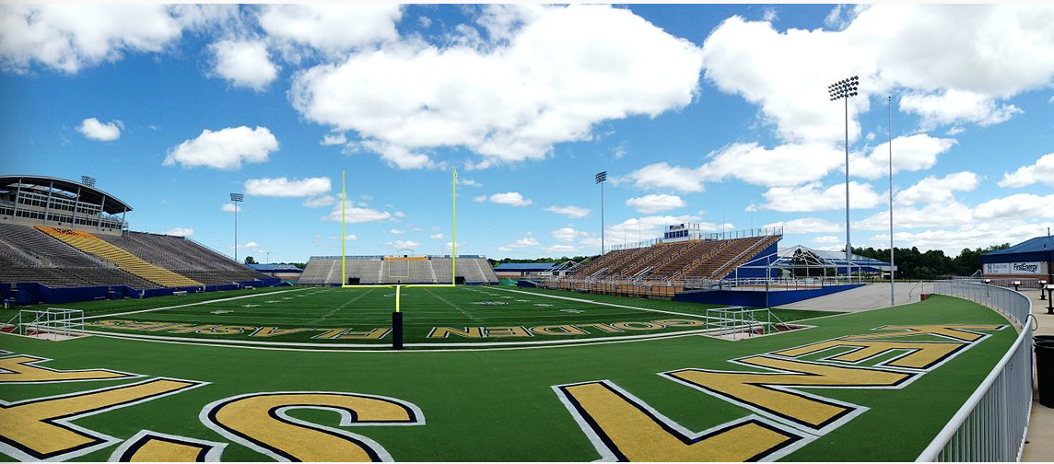

top 5

**Graffiti Stone**

**Kent State University，Kent Ohio**

